# C. Report No. 3 Software Requirement Specification

## 1. User Requirement Specification

### **1.1 Learner Requirement**

Learner is a person who access to the system as learner role. Learner can use following functions:

* Login
* View course
* View plan
* View program
* Learn lecture
* Take quiz
* View learning activity
* Manage discussion

### **1.2 Author Requirement**

* Manage discussion

## 2. System Requirement Specification

### **2.1 External Interface Requirement**

#### 2.1.1 User Interface

- The user interface uses Vietnamese.

- The user interface displays best on 1366x768 resolution on desktop.

#### 2.1.2 Hardware Interface

Desktop PC.

#### 2.1.3 Software Interface

Web application: work with browsers Firefox (v52 or higher), Chromes (v28 or higher), Internet Explorer (v10 or above) or with any web browser that supports HTML5 & CSS3

#### 2.1.4 Communication Protocol

Use HTTP protocol 1.1 for communication between the web browser and the web.

**2.2 System Overview Use Case**

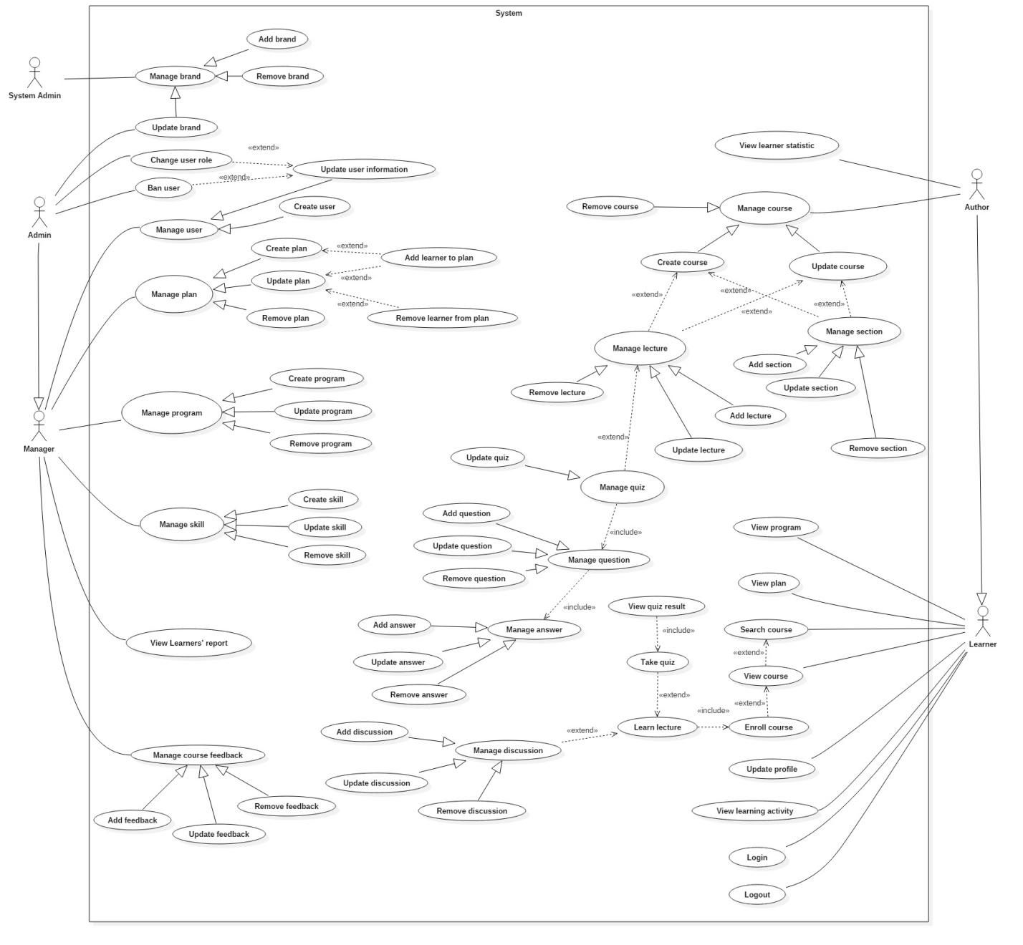

**2.3 List of Use Case**

**2.3.1. <Learner> Overview Use Case**

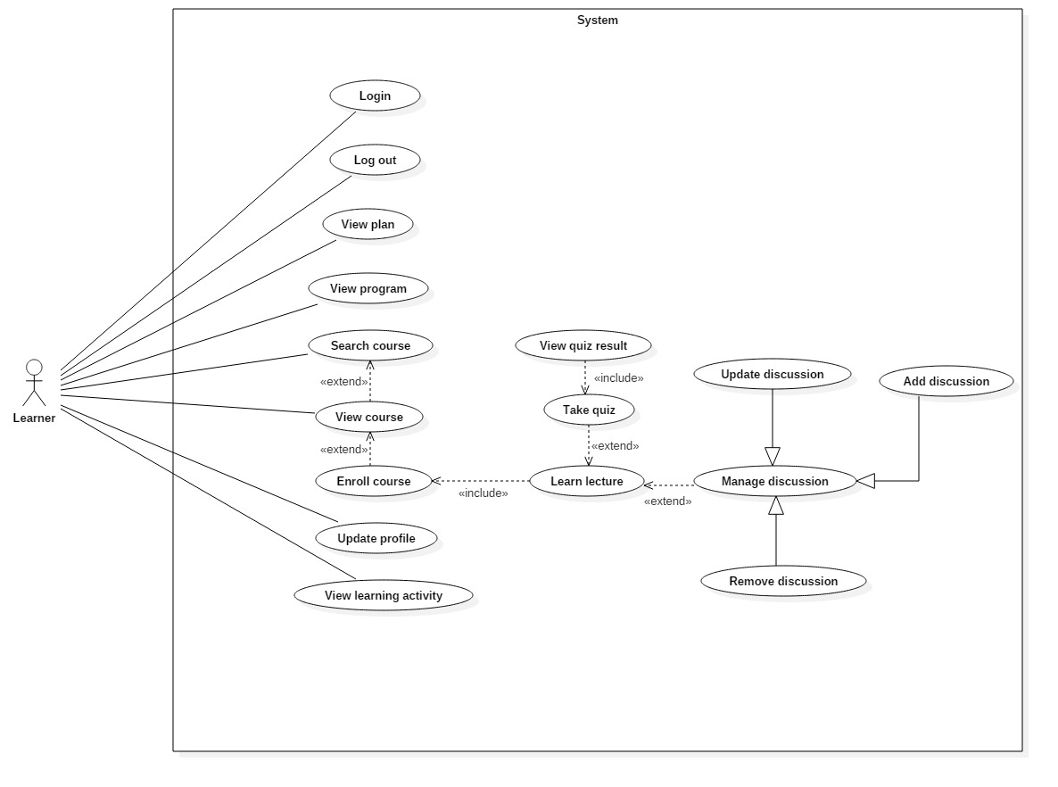

**Figure 1: <Learner> Overview Use Case**

##### **2.3.1.1 <Learner> Login**

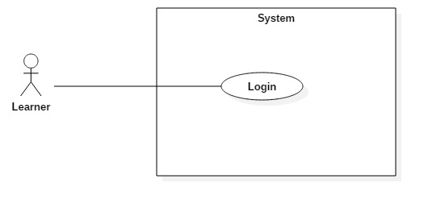

**Figure 2: <Learner> Login (UC_TRAISY1)**

|  |  |  |  |
| --- | --- | --- | --- |
| **USE CASE – UC_ TRAISY1** | | | |
| **Use Case No.** | UC_ TRAISY1 | **Use Case Version** | 0.2 |
| **Use Case Name** | Login | | |
| **Author** | Phạm Chánh Hưng | | |
| **Date** | 23/3/2018 | **Priority** | High |
| **Actor:**   * Learner   **Summary:**   * This use case allows authorized learner to login to system.   **Goal:**   * To login to the system.   **Triggers:**   * Actor sends login command.   **Preconditions:**   * Learner does not login yet.   **Post conditions:**   * Success: Actor accesses the system successfully. * Fail: System shows error messages.   **Main Success Scenario:**   |  |  |  | | --- | --- | --- | | ***Step*** | ***Actor Action*** | ***System Response*** | | 1 | Learner goes to login page | System require information:  Username: text input  Password: text input | | 2 | Learner inputs information  (Username and password) |  | |  |  | [Exception no.1] | | 3 | Learner sends command to login (Click “Đăng nhập” button after input login form). | System displays the home page. |   **Alternative Scenario:N/A**  **Exceptions:**   |  |  |  | | --- | --- | --- | | ***No*** | ***Cause*** | ***System Response*** | | 1 | Learner inputs wrong information. | System notices that “Thông tin đăng nhập không hợp lệ” |   **Relationships:** **N/A**  **Business Rules:**   * Username must be at least 5 characters. * Password must be at least 4 characters. * Pasword must be encrypted. | | | |

##### **2.3.1.2 <Learner> Log out**

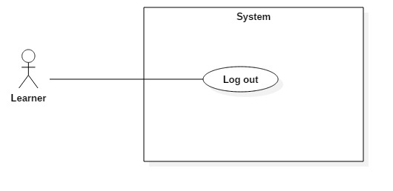

**Figure 3: <Learner> Logout (UC_TRAISY2)**

|  |  |  |  |
| --- | --- | --- | --- |
| **USE CASE – UC_ TRAISY2** | | | |
| **Use Case No.** | UC_ TRAISY2 | **Use Case Version** | 0.2 |
| **Use Case Name** | Logout | | |
| **Author** | Phạm Chánh Hưng | | |
| **Date** | 23/03/2013 | **Priority** | High |
| **Actor:**   * Learner   **Summary:**   * This use case allows user to logout the system.   **Goal:**   * To logout the system.   **Triggers:**   * Actor sends logout command.   **Preconditions:**   * Learner logged in the system.   **Post conditions:**   * Success: User session is removed and system displays login page. * Fail: System displays error messages.   **Main Success Scenario:**   |  |  |  | | --- | --- | --- | | ***Step*** | ***Actor Action*** | ***System Response*** | | 1 | Actor clicks “Đăng xuất” button. |  | |  |  | User session is removed and system displays login page. |   **Alternative Scenario: *N/A***  **Exceptions: N/A**  **Relationships:** N/A  **Business Rules:**   * Actor had accessed to the system. | | | |

##### **2.3.1.3 <Learner> View plan**

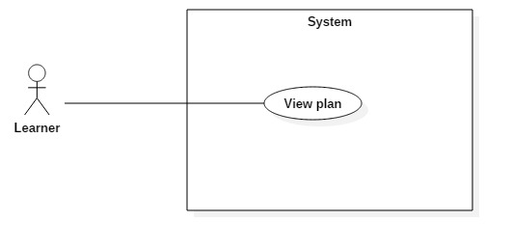

**Figure 4: <Learner> View plan (UC_TRAISY3)**

|  |  |  |  |
| --- | --- | --- | --- |
| **USE CASE – UC_ TRAISY3** | | | |
| **Use Case No.** | UC_ TRAISY3 | **Use Case Version** | 0.2 |
| **Use Case Name** | View plan | | |
| **Author** | Phạm Chánh Hưng | | |
| **Date** | 23/03/2013 | **Priority** | High |
| **Actor:**   * Learner   **Summary:**   * This use case allows learners to view a participated plan.   **Goal:**   * To view information of a specific plan that he/she has joined.   **Triggers:**   * Actor sends view plan command.   **Preconditions:**   * Learner logged in the system.   **Post conditions:**   * Success: System displays plan’s information. * Fail: System displays error messages.   **Main Success Scenario:**   |  |  |  | | --- | --- | --- | | ***Step*** | ***Actor Action*** | ***System Response*** | | 1 | Actor clicks on a specific plan. |  | |  |  | System navigates to the selected plan’s page with details of plan. |   **Alternative Scenario: *N/A***  **Exceptions: N/A**  **Relationships:** N/A  **Business Rules:**   * Learner must be a participant of the selected plan. | | | |

##### **2.3.1.4 <Learner> Update profile**

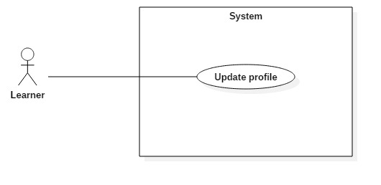

**Figure 5: <Learner> Update profile (UC_TRAISY4)**

|  |  |  |  |
| --- | --- | --- | --- |
| **USE CASE – UC_ TRAISY4** | | | |
| **Use Case No.** | UC_ TRAISY4 | **Use Case Version** | 0.2 |
| **Use Case Name** | Update profile | | |
| **Author** | Phạm Chánh Hưng | | |
| **Date** | 23/03/2013 | **Priority** | High |
| **Actor:**   * Learner   **Summary:**   * This use case allows learners to update their information.   **Goal:**   * To update profile.   **Triggers:**   * Learner sends update profile command.   **Preconditions:**   * Learner logged in the system.   **Post conditions:**   * Success: Account is updated successfully, and system displays the user profile page. * Fail: System displays error messages.   **Main Success Scenario:**   |  |  |  | | --- | --- | --- | | ***Step*** | ***Actor Action*** | ***System Response*** | | 1 | Actor clicks “Cập nhật” button in the update profile page. | [Exception 1]  [Exception 2] | |  |  | Account is updated successfully and system displays the user profile page. |   **Alternative Scenario:N/A**  **Exceptions:**   |  |  |  | | --- | --- | --- | | ***No*** | ***Cause*** | ***System Response*** | | 1 | Learner does not input required field. | System notices that guest need to input all these field:  - “Họ tên”: System display warning message: “Họ tên không được trống”.  - “Chức danh”: System display warning message: “Chức danh không được trống”.  - “Mật khẩu mới”: System display warning message: “Mật khẩu không được trống”.  - “Xác nhận lại mật khẩu”: System display warning message: “Xác nhận mật khẩu không được trống”. | | 2 | Guest input wrong some fields with requirement. | System notices that guest need to re-input all these field:  -“Mật khẩu”: System display warning message: “Mật khẩu phải từ 4 tới 30 ký tự”.  -“Xác nhận lại mật khẩu”: System display warning message: “Mật khẩu và xác nhận mật khẩu phải giống nhau”. |   **Relationships:** N/A  **Business Rules:**   * Fullname is not null and maximum of 45 characters * Title is not null * Password must be at least 4 characters | | | |

##### **2.3.1.5 <Learner> View Learning Activity**

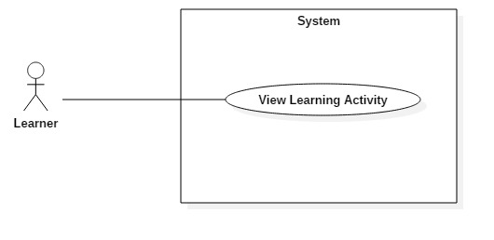

**Figure 6: <Learner> View Learning Activity (UC_TRAISY5)**

|  |  |  |  |
| --- | --- | --- | --- |
| **USE CASE – UC_ TRAISY5** | | | |
| **Use Case No.** | UC_ TRAISY5 | **Use Case Version** | 0.2 |
| **Use Case Name** | View Learning Activity | | |
| **Author** | Phạm Chánh Hưng | | |
| **Date** | 23/3/2018 | **Priority** | High |
| **Actor:**   * Learner   **Summary:**   * This use case allows authorized learner to view process of learning activity.   **Goal:**   * To view process of learning.   **Triggers:**   * Actor sends view process command.   **Preconditions:**   * Learner logged in the system.   **Post conditions:**   * Success: Actor accesses the system successfully. * Fail: System shows error messages.   **Main Success Scenario:**   |  |  |  | | --- | --- | --- | | ***Step*** | ***Actor Action*** | ***System Response*** | | 1 | Actor clicks to any plan or course in plan/course page | System displays learning activity/ process bar for each course and plan that learner has studied. | |  |  |  |   **Alternative Scenario: N/A**  **Relationships:** **N/A**  **Business Rules:**   * Learner must participate in plan to view learning activity of plan * Learner must enroll in course to view learning activity of course * Learner must study lecture in order to view learning process | | | |